Homework: Programming Languages
Problems for homework for the "Software Technologies" course @ Software University.
Submit this document as your homework.

JavaScript:
- Open the Browser Console.
- Create a JS function for calculating and returning the area of a rectangle.
- Create the constants needed and assign some random values:
- Execute the JS function in the Browser Console:
- Print the calculated area on the Browser Console in the following format: "The area of the rectangle is: areaValue sq.cm." :
- Example:
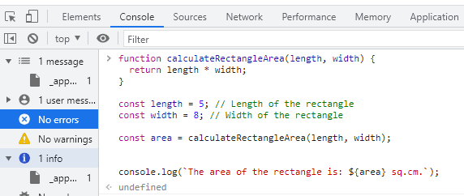
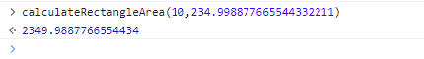

- Replace all example pictures with screenshots from your PC.

HTML & CSS
- Using the tutorial from the Exercise Document, Crate a simple Web Page that looks like the Example Below.
- Example:

- Replace all pictures with screenshots from your PC.

- Selfmade:
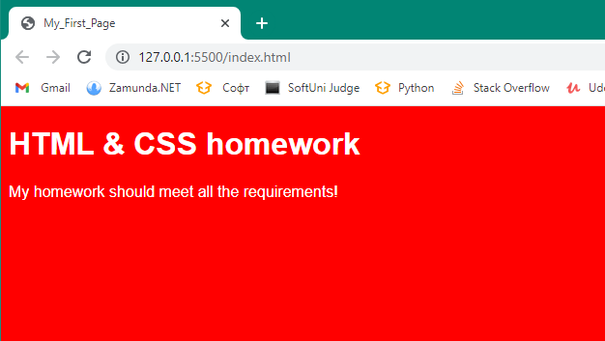

HTML:
<!DOCTYPE html>
<html lang="en">
<head>
<meta charset="UTF-8">
<meta http-equiv="X-UA-Compatible" content="IE=edge">
<meta name="viewport" content="width=device-width, initial-scale=1.0">
<link rel="stylesheet" href="style hw.css">
<title> My_First_Page</title>
</head>
<body>
<div class="container">
<h1>HTML & CSS homework</h1>
<p class="description">My homework should meet all the requirements!</p>
</div>

</body>
</html>

CSS:
body{
background-color: red;
color: white;
font-family: Arial, Helvetica, sans-serif;
}

- ChatGPT:
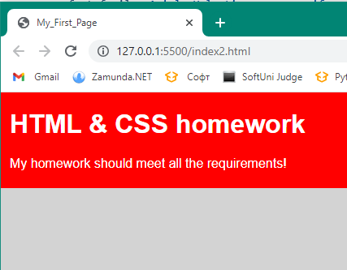

Code:
<!DOCTYPE html>
<html>
<head>
<title>My_First_Page</title>
<style>
body {
margin: 0;
padding: 0;
background-color: lightgray;
font-family: Arial, sans-serif;
}

.container {
padding: 1px;
background-color: red;
border: 20px solid red;
text-align: left;
color: white;
margin-left: -10px; /* Add a negative left margin to extend the background to the left */
margin-right: 20px; /* Adjust the right margin to control the width of the container */
}

h1 {
margin-top: 0;
font-family: "Arial", serif;
}

.description {
margin-bottom: 0;
}
</style>
</head>
<body>
<div class="container">
<h1>HTML & CSS homework</h1>
<p class="description">My homework should meet all the requirements!</p>
</div>
</body>
</html>

